Chapter 14, Solution 94.

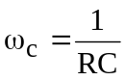

We make R and C as small as possible. To achieve this, we connect 1.8 k and 3.3 k in parallel so that

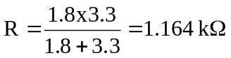

We place the 10-pF and 30-pF capacitors in series so that

C = (10x30)/40 = 7.5 pF

Hence,
